

**SPORT AND HEALTH SCIENCES**

College of Life and Environmental Sciences

DISSERTATION

BSc (Hons) Exercise and Sport Science

**TITLE: The Relationship Between Open Play Kicking, Turnovers Conceded and Team Success in Rugby Union**

Submitted as part requirement

**For the degree of BSc (Hons) Exercise and Sport Science**

to the College of Life and Environmental Sciences,

Sport and Health Sciences,

University of Exeter

Benjamin Eedy

SUPERVISING TUTOR: Professor Sam Vine DATE OF SUBMISSION: 07/05/2024

# Acknowledgements

I would like to thank Professor Sam Vine for his supervision and guidance in this dissertation study, and Thomas Elliott and Hannah Burton for providing the game footage and the tools/support needed to collect the relevant data and improve as a performance analyst throughout my final year. I’d also like to thank my former colleagues during my placement year with Newport High School and Dragons RFC, who helped inspire my dissertation topic and initiate my future goals in performance and data analysis. Finally, I’d like to thank my family and friends for their invaluable support throughout my entire degree.

Table of Contents

Acknowledgements 2

List of Tables 4

List of Figures 4

Abstract 5

Chapter 1: Introduction 6

Chapter 2: Methods 9

2.1 Participants 9

2.2 Equipment and Software Used. 9

2.3 Selection of PIs. 10

2.4 Procedure and Coding Template. 11

2.5 Reliability 12

2.6 Statistical Analysis. 13

Chapter 3: Results 14

3.1 PIs Correlated with A Winning/Losing Outcome by Time Interval 15

3.2 PIs Correlated with a Winning/Losing Outcome by Pitch Zone 16

3.3 Other PIs 17

Chapter 4: Discussion 19

4.1 Territorial Kicks 19

4.2 Competitive Kicks 22

4. 3 Turnovers conceded 23

4.4 Limitations 24

4.5 Conclusion 25

Chapter 5: References 26

Chapter 6: Appendix 29

Appendix A 29

Appendix B 30

Appendix C 31

# List of Tables

Table 1. Table representing odds ratios and 95% Confidence Intervals of Kicks in Open Play and Kicking PI subgroups. 18

Table 2. Table representing odds ratios and 95% Confidence Intervals of Turnovers Conceded and Turnover PI sub-groups 18

Table 3. list of operational definitions 30

Table 4. List of fixtures included in the analysis. 31

# List of Figures

Figure 1. The final coding template 11

Figure 2. Coding Process Template 12

Figure 3. The Odds Ratios of Kicks in Play and Turnovers Conceded during 20-minute time intervals. 15

Figure 4. The Odds Ratios of Competitive and Territorial Kicks during 20-minute time intervals 15

Figure 5. A visualisation of each Pitch Zone and respective kicking odds ratios 16

Figure 6. The Odds Ratios of Territorial Kicks within each Pitch Zone. 17

Figure 7. Match statistics gathered by Oval Insights in 2023 21

Figure 8. The Dissertation Information Sheet 29

Abstract

This study examined the correlation between contextualised performance indicators (PIs) and a winning outcome in sub-elite rugby union (RU) games, specifically the number, type, location, and timing in the game of kicks in open play and turnovers conceded. A sample of 30 games played by a sub-elite collegiate team was analysed before performing logistic regression on the results to produce odds ratios (ORs) for each PI. Overall kicks in open play (OR=1.73) and territorial kicks (OR=1.61) in the final 20 minutes, and territorial kicks in the opposition’s 22-metre area (OR=1.65) were correlated with a winning outcome. Competitive kicks during the 21-40-minute interval (OR= 0.24) and in the opposition’s 22-metre area (OR= 0.39) were correlated with a losing outcome. Turnovers conceded were not correlated with game outcome. Results indicate that teams should kick territorially and longer during the latter stages of the game and further up the field whilst avoiding competitive kicks to increase their chances of winning. Further research should aim to include as many external and contextual variables as possible in their statistical model to comprehensively examine the effect of discriminatory PIs and provide actionable insights for RU practitioners.

**Keywords:** Rugby Union, Contextualised Performance Indicators, Logistic Regression, Kicks in Open Play, Turnovers Conceded.

**Word Count:** 4,983

# Chapter 1: Introduction

In Rugby Union (RU), the ultimate aim and indicator of success is victory and outscoring one’s opponent (van Rooyen, Lambert and Noakes, 2006). Since the era of professionalism in 1995, along with increased implications of success or failure, professional teams have strived to implement techniques to improve performance and increase their chances of success in competition. One such technique is the use of performance analysis to provide objective feedback and data to improve decision-making, influence game tactics and optimise performance (Mayes, 2013). Performance analysis has evolved since RU transitioned to professionalism, evolving from hand-written notational analysis to computer-based and video capture technologies that gather and analyse huge volumes of match and player-based data (Colomer *et al.*, 2020). Research has shown that coaches and analysts collaborate and use this data to structure practice, analyse the opposition and evaluate their team’s performance by reflecting on specific performance indicators (PIs) associated with success (Eaves and Hughes, 2003; Bremner, Robinson and Williams, 2013). This PI data can be used to objectively describe and summarise game events and the performances of teams and players. These aspects could relate to the scoring, attacking, defensive, and kicking performances of the team and include a range of statistics such as percentage of possession and territory, number of tries and points scored, and numerous other in-game statistics. These PI data and statistics are regularly gathered by sports teams and analytics companies, as well as being displayed by broadcasters during games to give deeper insights to fans and pundits.

In the literature, many PIs and their effect on success in RU have been investigated. Their continued evaluation is necessary due to the constant evolvement of RU’s laws and the changing tactical trends employed by teams (Eaves and Hughes, 2003; Vahed, Kraak and Venter, 2016). There is also a need to distinguish research findings from the different types of teams investigated, where a limited number of studies have explored the differences between international elite and domestic elite teams. For example, prior research showed that tackle completion and successful mauls won were more significant in international winning teams (Scott *et al.*, 2023) whilst Vaz *et al.* (2010) found no significant differences between international winners and losers when the winning margin was less than 15 points (Vaz, Rooyen and Sampaio, 2010). However, Vaz *et al.* (2010) also state that successful domestic elite teams execute more kicks and win more territory, whilst losing teams execute more passes and rucks. It is important to note, however, that this archival data is from 2006, and contextual factors surrounding these PIs were not explored. Common findings nonetheless consistently state that winning teams score more tries and complete a higher proportion of their tackles (Ortega, Villarejo and Palao, 2009; Vaz, Rooyen and Sampaio, 2010). These PIs, however, are intuitive, clearly demonstrating that winning teams attack and defend more effectively. Further research into the discriminating factors between winners and losers shows that winning teams kick more in open play (Ortega, Villarejo and Palao, 2009; Bennett *et al.*, 2019; Scott *et al.*, 2023) and kick in their opponent’s half (Hughes *et al.*, 2017). Losing teams also concede more turnovers and miss more tackles (Vaz, Rooyen and Sampaio, 2010; Sella *et al.*, 2019; Scott *et al.*, 2023). Research by Bremner *et al.* (2013) explores turnover PIs further by comparing their association with match outcomes during ten-minute intervals of the match. They found that turnovers in contact in the first half and handling errors during the second half of a game were most associated with a loss (Bremner, Robinson and Williams, 2013).

However, due to the complexity of RU and the large number of confounding variables that can influence performance, research methodologies and the variables accounted for vary greatly. Many previous studies employ hand-written notational analyses, introducing error rates when transferring the data to computer databases (Eaves, Hughes and Lamb, 2005), while others use secondary data analysis on data provided by sports analytics companies such as Opta (Scott *et al.*, 2023). Data gathered by Opta may be questioned regarding inter and intra-reliability issues, as they do not share their reports on this reliability in RU. Other studies gather and code their own set of data to ensure observer reliability on the PIs they inspect (Jones, James and Mellalieu, 2008; Bremner, Robinson and Williams, 2013). Much of the literature additionally lacks specific contextual details on the PIs investigated (such as open play kicks and turnovers conceded), not addressing the association of their different types, locations, and timings. Bremner *et al.* (2013) are one of the only studies to include time intervals within their analysis models. A systematic review by Colomer *et al.* (2020) reinforces this judgement by stating that performance analysis literature lacks contextual information surrounding PIs such as opposition behaviour, venue location, the period within the match and pitch location of the PI occurrence (Colomer *et al.*, 2020). Further scrutiny from den Hollander *et al.* (2018) states that many video analysis studies, such as Prim *et al.* (2006) lack statistical power due to low sample sizes (Prim, van Rooyen and Lambert, 2006). They also raise concerns over the usefulness of the findings for practitioners (e.g. coaches and players) and express that more specific contextual information, like those expressed by Colomer *et al.* (2020), is needed for actionable insights. These insights could then help inform practitioners on match tactics, team selection and training methods. Examining just one team’s PI data can also mitigate the confounding variables of studying multiple teams, such as different team playing styles (Jones, James and Mellalieu, 2008). This can help directly identify what PIs are correlated with winning. By using a sufficient sample of games from one team as well as investigating the contextual information underpinning winning PIs, research can directly inform practitioners on how to increase the chances of success in RU.

This study aims to investigate the correlation which contextual PIs have with a sub-elite team’s success in RU, specifically, the number, type, location, and timing of kicks in open play and turnovers conceded. Previous research limitations will be accounted for by performing primary data collection and analysis, utilising 2 seasons’ worth of games played by one team as the sample, and indicating what specific PIs are linked with success. It is hypothesised that a greater number of territorial kicks within the team’s own half during the early and later stages of the game will be associated with a winning outcome, due to the importance of gaining territory for success in RU (Vaz, Rooyen and Sampaio, 2010). Fewer unforced turnovers within the team’s own half and during the later periods of the game are also hypothesised to be associated with a winning outcome, as Bremner *et al.* (2013) found that contact and handling turnovers were associated with a negative effect on game outcome (Bremner, Robinson and Williams, 2013).

# Chapter 2: Methods

2.1 Participants*.*

One British Universities and Colleges Sport (BUCS) Super Rugby men’s team was retrospectively analysed for 31 games (15 wins, 15 losses and 1 draw) spanning the 2022/23 and 2023/24 seasons. Drawn games were removed from the analysis due to insufficient sample size. Due to low statistical power reported in sample sizes of 9 games (Prim, van Rooyen and Lambert, 2006), and to reduce the risk of a type 2 error, 30 games spanning 2 seasons were included. Greater statistical power and significance were also seen in studies including over 20 games (Colomer *et al.*, 2020). Ethical consent was not required from the team as their match footage was publicly available, but they were informed of the study’s aims and information. The information sheet used to is included in Appendix A. BUCS Super Rugby refers to the highest level of university RU in the United Kingdom (BUCS, 2023a), where, since its inception in 2017, over 100 players have gone on to play at an elite professional level, with many becoming full internationals for their respective nations (BUCS, 2023b).

## 2.2 Equipment and Software Used.

Several Sony 4k hand-held cameras (Sony Corporation, Japan) mounted on standard tripods were used to capture the footage of all games, using Firewire connections to allow the capture of the footage onto a MacBook Pro (Apple Inc., USA). All game footage was stored on an external hard drive (Shenzhen Union Integrity Technology Corporation, China). The Hudl Sportscode Elite analysis package (Agile Sports Technologies Inc., USA, Version 12.26.0) was then used for the notational analysis of kicks in open play and turnovers conceded, classifying each PI by their type/source, sub-group, timing, and location. Hudl Sportscode was used due to the researcher’s familiarity with the software and its industry-leading features and popularity among elite teams across many different sports, including RU (Martinez Arastey, 2018). It has also been found that the error rate in gathering data increases when transferring handwritten notational analyses to software databases such as Excel (Eaves, Hughes and Lamb, 2005), suggesting that computerised and automated systems have greater reliability. The Matrix, Sorter and Database feature was then used to export the PI data into a Microsoft Excel spreadsheet (Microsoft Corporation, USA, Microsoft Excel 2021, Version 16.81) for analysis. After cleaning the data and formatting it appropriately, this data was then transferred to SPSS for statistical analysis (IBM, USA, Version 29.0.1.0).

## 2.3 Selection of PIs.

The PIs selected for this study were adapted and developed from the current University of Exeter analysts and World Rugby definitions, as well as PIs used in previous literature, such as sources of turnovers (Bremner, Robinson and Williams, 2013) and kicks from hand/open play (Bennett *et al.*, 2019). Kicks in open play (kicks out of hand where both teams are contesting for the ball) and turnovers conceded (where a team concedes possession to the other) were grouped into time intervals of the game, location on the pitch, kick/turnover sub-group, and type of kick/source of turnover (World Rugby, 2024). The groups of PIs can be viewed in the coding template (Figure 1), with kicks classified as territorial or competitive and turnovers classified as forced or unforced. The full operational definitions of PI sub-groups, types of kicks and sources of turnovers are displayed in Appendix B.

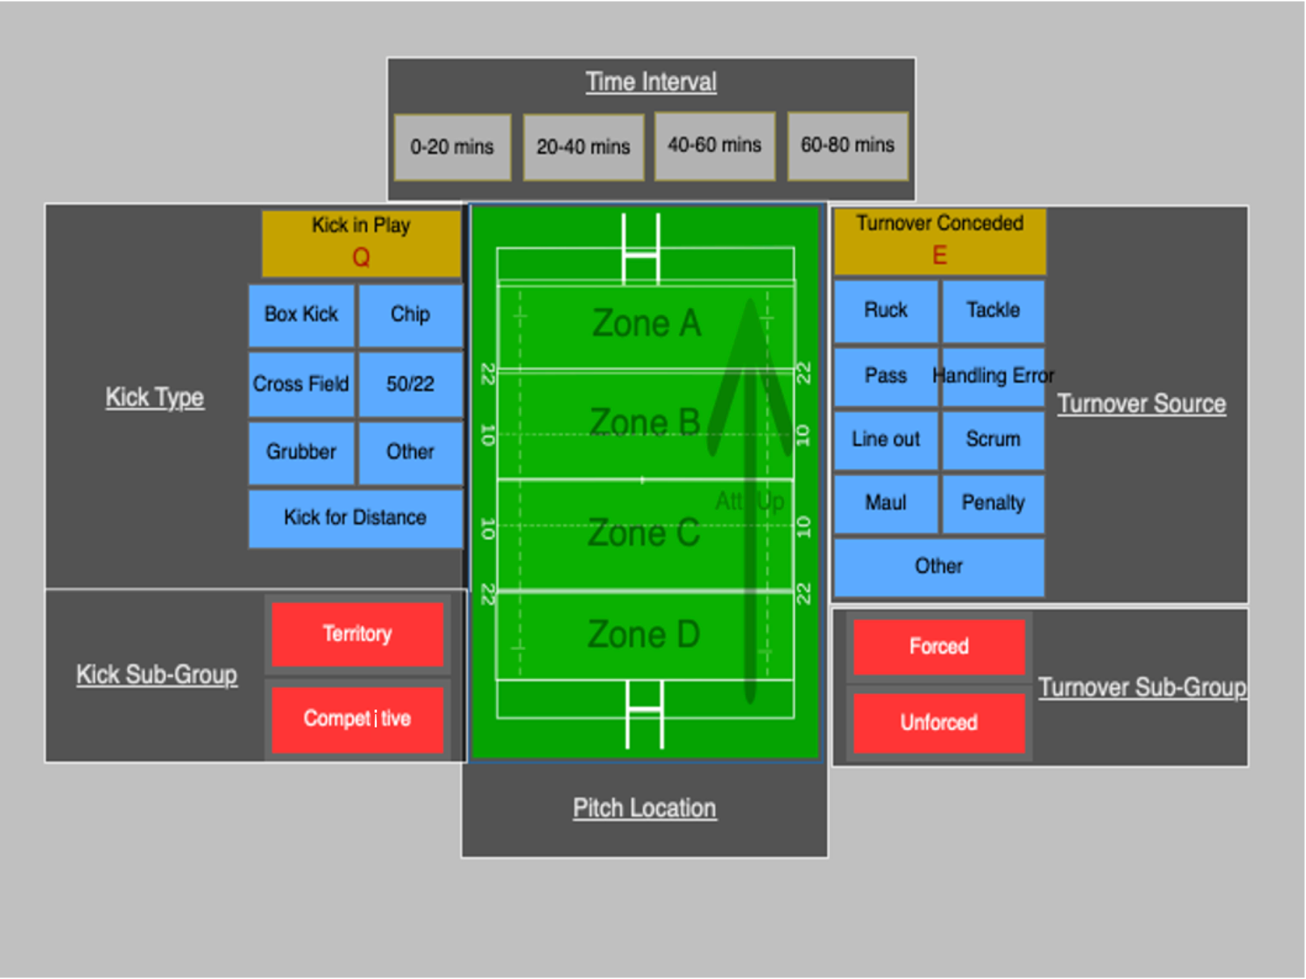

Figure 1. The final coding template designed using Hudl Sportscode. Used to code the match PIs and statistics in each of the 30 games. The dark squares with underlined text represent a PI group, while the arrow pointing up on the pitch indicates the team's direction of attack whilst in possession. Code buttons used include the time intervals, which created video instances in the Hudl timeline. All other buttons used were labels used to tag each video instance created. The dark squares representing PI groups and the image of the rugby pitch and arrow were inactive buttons, used to segment the template and provide clarity.

## 2.4 Procedure and Coding Template.

The coding procedure was first piloted on two games separate from the experimental sample so as not to influence the study’s validation (O’Donoghue, 2013). This allowed the researcher to improve the workflow logistics and produce the final code window (Figure 1). Each match was skimmed in lapsed time to search for kicks in open play and turnovers conceded, allowing the researcher to pause, rewind and move frame-by-frame to produce accurate data collection, as supported by previous research (Vahed, Kraak and Venter, 2016). When each kick or turnover was spotted, the appropriate code button was activated, before applying the appropriate labels to describe the instance before deactivating the code button, consequently updating the statistics matrix of the Hudl timeline. The coding workflow, process and example PI output matrix are represented in Figure 2. Once all games were coded, their individual output matrixes were exported as .csv files and converted to Excel files before being collated to create one complete dataset of all 30 games.

Figure 2. Coding Process Template. Each stage represents a step in the coding process, with highlighted areas of the code window to represent the order in which the code buttons and labels were activated. Once the entirety of the game was coded, an output matrix was produced to represent the coded PIs of the game.

## 2.5 Reliability

Intra and inter-observer reliability were assessed between a sample of 2 games before data collection on the sample of 30 games. Due to this small sample, a standard absolute percentage agreement calculation was used. Intra-observer reliability assessment was carried out by the principal analyst, coding the separate sample of games once before coding the same games a week later to reduce the chance of a recall effect. Inter-observer reliability was assessed by the principal analyst and a separate analyst who had over 3 years of experience as a performance analyst within rugby and familiarity with similar code windows/workflows. The absolute percentage agreement for intra and inter-observer reliability was calculated to be 100% and 91% respectively, indicating high to perfect levels of agreement (Graham, Milanowski and Westat, 2014).

## 2.6 Statistical Analysis.

Once all reliability tests were completed, the sample of 30 games was coded by the principal analyst. This produced a statistical breakdown of the kicking and turnover PIs within each 20-minute interval of each game in the form of an output matrix in Hudl Sportscode. This data was then exported to Excel for data cleaning and exploratory analysis before being transferred to SPSS for statistical analysis. Logistic regression based on a binary match outcome (Win = 1/Loss = 0) was used to assess the relationship between the frequency of each PI sub-group and winning/losing. The obtained odds ratios (ORs) were used to assess the odds that a win/loss would occur given the occurrence of a certain PI compared to its non-occurrence (Szumilas, 2010).

ORs are commonly used in health research to study the link between risk factors and disease (Tenny and Hoffman, 2024). They provide information about how much more likely one event is to happen given the occurrence of another, compared with the likelihood of the first event happening without the second. In this instance, ORs provided information about how much more likely a win was to occur given the occurrence of a certain PI (e.g. a territorial kick in Pitch Zone B) compared to the likelihood of a win without the presence of the PI. An OR >1 indicates a win is more likely to occur, whilst an OR<1 indicates a win is less likely to occur (Dickinson, 2022). An OR of ≥1.5 was interpreted as a meaningful correlation with winning, whilst an OR of ≤0.5 was interpreted as a meaningful correlation with losing (Grimes and Schulz, 2008). An OR>0.5 and <1.5 was interpreted as having an unimportant effect on match outcome. Due to varying and low sample sizes, ORs for specific kick types and turnover sources were not utilised. Confidence intervals (CI) of 95% were obtained for all ORs to display the variance of the data, whilst p values were not used due to the number of tests carried out and the lack of their use in previous studies utilising logistic regression (Bremner, Robinson and Williams, 2013; Parmar *et al.*, 2018).

# Chapter 3: Results

A logistic regression analysis of the data revealed that of the PIs and PI sub-groups investigated, 3 PIs had a positive correlation with a winning outcome; overall kicks in play (OR= 1.73, 95% CI= 1.08, 2.78) (Figure 3) and territorial kicks (OR= 1.61, 95% CI= 0.98, 2.63) (Figure 4) during the 61–80-minute interval, as well as territorial kicks in the opposition’s 22-metre area (Pitch Zone A) (OR= 1.65, 95% CI= 0.13, 21.55) (Figures 5 and 6).

Two other PIs had a negative correlation with game outcome: competitive kicks during the 21–40-minute interval (Figure 4) (OR= 0.24, 95% CI= 0.05, 1.06) and in the opposition’s 22-metre area (OR= 0.39, 95% CI= 0.08, 1.92) (Figures 5 and 6).

All other PI sub-groups had no meaningful correlation with winning or losing, but it is of note that the ORs of overall turnovers conceded had an observed negative relationship with time in the game (Figure 3), despite no Turnover sub-group displaying a meaningful correlation. OR and 95% CI data of Kick and Turnover PI sub-groups are represented in Tables 1 and 2 respectively.

## 3.1 PIs Correlated with A Winning/Losing Outcome by Time Interval

Figure 3. The Odds Ratios (ORs) of Kicks in Play and Turnovers Conceded during 20-minute time intervals. The green line at OR 1.5 depicts the boundary for a positive correlation with a winning outcome, whilst the red line at OR 0.5 depicts the boundary for a negative game outcome. Only ‘Kick in Play’ achieves a positive correlation with a winning outcome (OR= 1.73) during the 61-80 minute time interval, whilst ‘Turnover Conceded’ ORs appear to have a negative relationship with time-interval, but do not achieve an OR below 0.5.

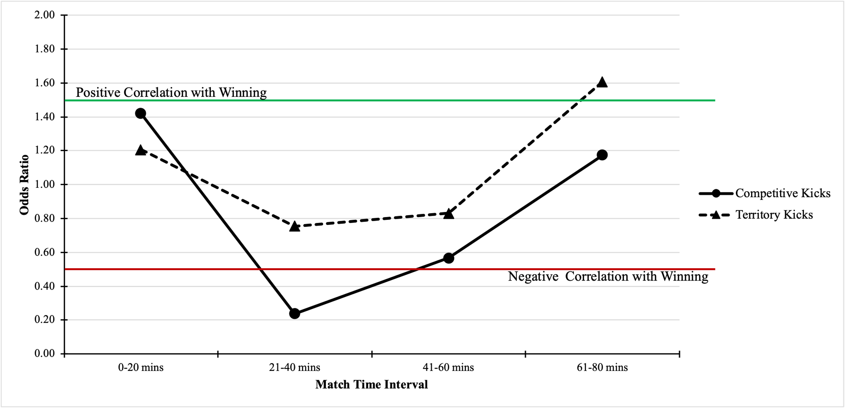

Figure 4. The Odds Ratios (ORs) of Competitive and Territorial Kicks during 20-minute time intervals. The green line at OR 1.5 depicts the boundary for a positive correlation with a winning outcome, whilst the red line at OR 0.5 depicts the boundary for a negative game outcome. Only Territorial Kicks during the 61–80-minute interval achieved an OR correlated with a winning outcome (OR= 1.61), whilst Competitive Kicks during the 21-40-minute interval were associated with a negative outcome (OR= 0.24).

## 3.2 PIs Correlated with a Winning/Losing Outcome by Pitch Zone

A representation of the Pitch Zones and kicking PI ORs examined is displayed below to help visualise the pitch locations (Figure 5). Territorial kicks in Zone A were correlated with a winning outcome but with a high variance in the data (OR= 1.65, 95% CI= 0.13, 21.55) (Figure 6). Competitive kicks within the same zone however were correlated with a losing outcome (OR= 0.39, 95% CI= 0.08, 1.92).

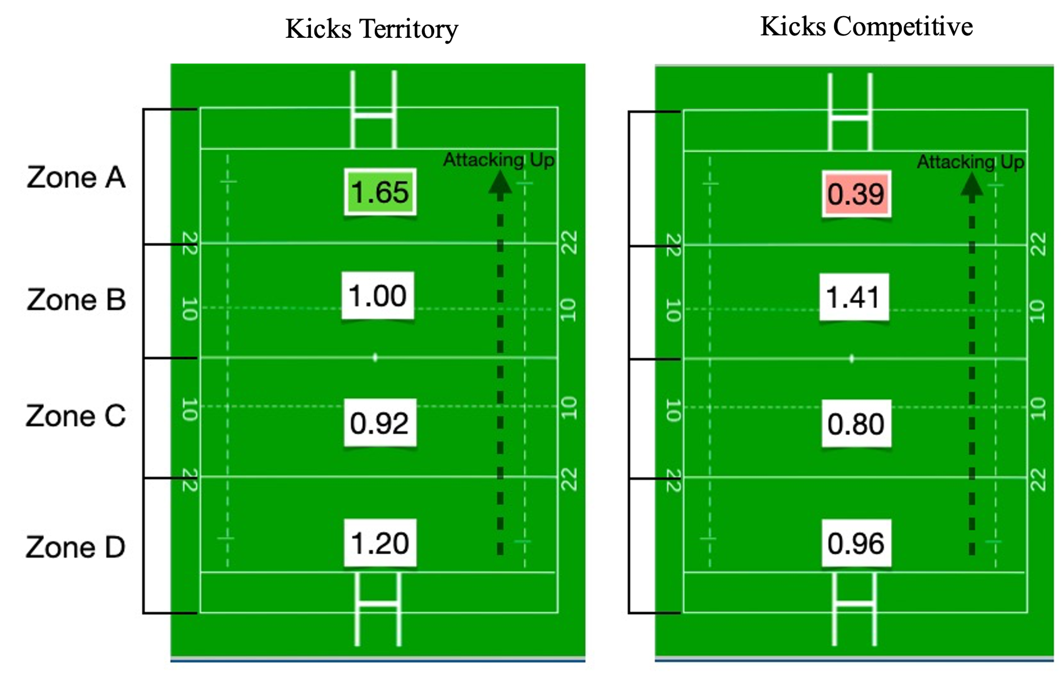

Figure 5. A visualisation of each Pitch Zone was investigated, with a black arrow to depict the team's direction of attack. Territorial Kicks within Zone A (the opposition's 22-metre area) produced an odds ratio (OR) of 1.65, a positive correlation with winning. Competitive kicks in Zone A have an OR of 0.39, a negative correlation with a winning outcome.

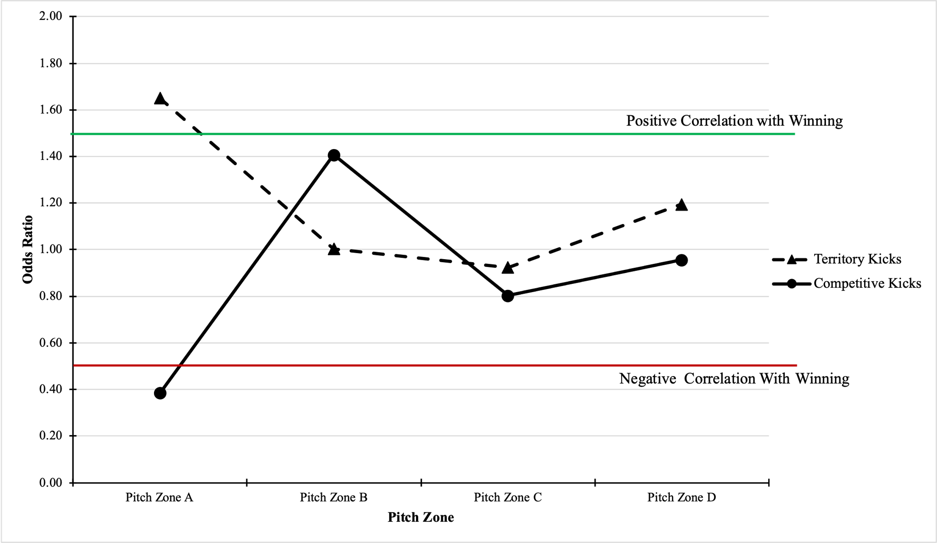

Figure 6. The Odds Ratios (OR) of Territorial Kicks within each Pitch Zone. The green line at OR 1.5 depicts the boundary for a positive correlation with a winning outcome, whilst the red line at OR 0.5 depicts the boundary for a negative game outcome. Territorial Kicks within Pitch Zone A achieved an OR correlated with a winning outcome (OR= 1.65). Competitive Kicks within Zone A were found to be negatively correlated with game outcome (OR= 0.39).

## 3.3 Other PIs

Kicking PI sub-groups of note that failed to meet the 0.5 OR thresholds for a negative correlation include overall kicks in play during the 21–40-minute interval (OR= 0.58, 95% CI= 0.34, 0.98) and competitive kicks during 41-60 minutes (OR= 0.57, 95% CI= 0.20, 1.62). Those that appeared close to a positive correlation (OR≥ 1.5) include competitive kicks, 0-20 minutes (OR= 1.42, 95% CI= 0.71, 2.81) and in Pitch Zone B (OR= 1.41,95% CI= 0.64, 1.92) (Table 1).

Table 1. Table representing odds ratios (OR) and their respective 95% Confidence Intervals (95% CI) of Kicks in Open Play and Kicking PI sub-groups. ** depicts an OR that is positively correlated with a winning outcome (OR ≥ 1.5). * Depicts an OR that is negatively correlated with a winning outcome (OR≤ 0.5).

|  |  |  |  |  |  |  |
| --- | --- | --- | --- | --- | --- | --- |
|  | Kicks in Open Play | | Kicks Competitive | | Kicks Territory | |
|  | OR | 95% CI | OR | 95% CI | OR | 95% CI |
| Total Frequency | 0.98 | 0.87, 1.09 | 0.86 | 0.62, 1.20 | 1.00 | 0.87, 1.14 |
| 0-20 mins | 1.35 | 0.92, 1.98 | 1.42 | 0.71, 2.81 | 1.21 | 0.85, 2.01 |
| 21-40 mins | 0.58 | 0.34, 0.98 | 0.24* | 0.05, 1.06 | 0.75 | 0.50, 1.13 |
| 41-60 mins | 0.72 | 0.50, 1.02 | 0.57 | 0.20, 1.62 | 0.83 | 0.61, 1.14 |
| 61-80 mins | 1.73** | 1.08, 2.78 | 1.18 | 0.47, 2.82 | 1.61** | 0.98, 2.63 |
| Zone A | 0.87 | 0.25, 3.11 | 0.39* | 0.08, 1.92 | 1.65** | 0.13, 21.55 |
| Zone B | 1.07 | 0.63, 1.82 | 1.41 | 0.64, 1.92 | 1.00 | 0.42, 2.42 |
| Zone C | 0.92 | 0.76, 1.10 | 0.80 | 0.49, 1.32 | 0.92 | 0.75, 1.14 |
| Zone D | 1.21 | 0.87, 1.70 | 0.96 | 0.37, 2.49 | 1.20 | 0.86, 1.67 |

Although no Turnover PI sub-groups achieved a negative or positive correlation, it can be noted that there appears to be a negative relationship between overall turnover ORs and time in the game (Figure 3). Turnovers conceded during the final 20-minute interval of the game appear close to having a negative correlation with game outcome, despite not reaching the 0.5 threshold (OR= 0.64, 95% CI= 0.40, 1.03) (Table 2).

Table 2. Table representing odds ratios (OR) and their respective 95% Confidence Intervals (95% CI) of Turnovers Conceded and Turnover PI sub-groups. No singular OR was found to be correlated with a positive or negative game outcome.

|  |  |  |  |  |  |  |
| --- | --- | --- | --- | --- | --- | --- |
|  | Turnovers Conceded | | Turnovers Forced | | Turnovers Unforced | |
|  | OR | 95% CI | OR | 95% CI | OR | 95% CI |
| Total Frequency | 0.91 | 0.72, 1.15 | 0.95 | 0.77, 1.28 | 0.92 | 0.72, 1.17 |
| 0-20 mins | 1.30 | 0.79, 2.12 | 1.23 | 0.70, 2.16 | 1.09 | 0.60, 1.97 |
| 21-40 mins | 1.04 | 0.60, 1.83 | 0.88 | 0.44, 1.77 | 1.29 | 0.73, 2.30 |
| 41-60 mins | 0.83 | 0.53, 1.29 | 1.17 | 0.62, 2.21 | 0.75 | 0.44, 1.26 |
| 61-80 mins | 0.64 | 0.40, 1.03 | 0.81 | 0.46, 1.43 | 0.84 | 0.48, 1.46 |
| Zone A | 1.20 | 0.84, 1.73 | 1.42 | 0.91, 2.21 | 1.20 | 0.72, 1.99 |
| Zone B | 0.86 | 0.60, 1.23 | 0.73 | 0.46, 1.14 | 0.98 | 0.66, 1.46 |
| Zone C | 0.77 | 0.54, 1.12 | 0.81 | 0.48, 1.38 | 0.74 | 0.48, 1.14 |
| Zone D | 1.07 | 0.61, 1.86 | 0.99 | 0.48, 2.01 | 0.87 | 0.41, 1.87 |

Chapter 4: Discussion

This study used a 30-game sample and a logistic regression analysis to examine the correlation between different PIs occurring in different time intervals and pitch locations and the result of each game (win/loss). The PIs investigated consisted of competitive/territorial kicks in open play and unforced/forced turnovers conceded, with the time intervals split into 20-minute segments of the standard 80-minute game and the pitch being separated into 4 different areas. ORs were used to assess the strength of relationships between each PI and game outcome. PIs with a positive correlation with a winning outcome included overall kicks in open play and territorial kicks during the 61–80-minute interval and within the opposition’s 22-metre area (Zone A), with overall kicks in play in the last 20 minutes of the game achieving the strongest correlation with winning. PIs with a negative correlation/associated with a losing outcome included competitive kicks during the 21–40-minute interval and within the opposition’s 22-metre area (Zone A). All other PIs failed to show a meaningful correlation, although it is important to note that the OR of overall turnovers conceded showed a negative relationship with the time in the game. The results regarding territorial kicks later in the game partially met the hypothesis but their location nor the non-significant results regarding turnovers conceded was not successfully predicted. These findings could inform coaches and players on game tactics to help produce a winning outcome by emphasising the use of territorial kicks later in a game and closer to the opposition’s try line, whilst avoiding competitive kicks during the 21-40-minute interval and within the opposition’s 22-metre area.

## 4.1 Territorial Kicks

These results indicate the importance of an effective territorial kicking strategy (kicks that usually give up possession in return for greater territory) for success in RU instead of a competitive kicking one (generally shorter kicks to compete for and retain the ball). This particular finding is replicated by many other studies (Vaz, Rooyen and Sampaio, 2010; Scott *et al.*, 2023). To succeed and win games in RU, teams must progress the ball up the field to score tries and points, typically starting their possession closer to the opposition’s try line (Coughlan *et al.*, 2019). The current study could indicate that it is beneficial for teams to progress the ball by kicking long, defending, and then regaining the ball closer to the opposition’s try line rather than kicking the ball shorter for a greater chance of immediately retaining the ball. A territorial kicking strategy is supported by statistics gathered by Oval Insights, which explains the difficulty of progressing the ball up the pitch via carrying. Therefore, teams should opt to kick long and regain the ball higher up the field to score points (Oval Insights, 2024). This is supported by the fact that over half of the tries scored in tier-one international matches at the 2023 World Cup originated from possession in the opposition’s 22-metre (Oval Insights, 2024). The significance of kicking over carrying intensifies with higher competition levels, potentially amplifying the correlation between territorial kicks and success. Including a professional team in the sample, as opposed to a collegiate elite side, may enhance this relationship due to the superior defensive quality at professional levels. As teams move down the professional pyramid, defensive efficacy may decrease relative to the opponent's attack, elevating the value of carrying to advance the ball. Oval Insights supports this notion from statistics they gathered from international, professional and domestic games in 2023 (Oval Insights, 2024), with the team used in this study sitting one level below “Domestic” within the professional pyramid outlined in Figure 7. Research findings by Mosey *et al.* (2020) concur with this judgement and are one of the only authors to include a list of practical implications in their conclusions. They also state that teams should implement a match strategy which maximises the number and distance of their kicks, whilst limiting the opposition’s own kicking strategy (Mosey and Mitchell, 2020).

Figure 7. Match statistics gathered by Oval Insights from games in 2023. They show how the importance of progressing the ball by kicking increases the further up the professional pyramid a game is, whilst also depicting how the importance of carrying the ball increases the further down the pyramid the game is.

The present study emphasizes the significance of executing territorial kicks later in games and higher up the field. It suggests that the sample team utilized long kicks to maintain a lead, forcing opponents to attack from deep in their half/22-metre area. This tactic may also have been employed to rescue losing games by regaining possession further up the field. However, this study lacks an analysis of point-scoring timelines in individual games, which could offer deeper insights into kicking tactics. The large variance in 95%CI values for kicks in Pitch Zone A (Table 1) should be noted too, and further research should scrutinise the correlation between kicks in this area and game outcome by analysing other PIs and match events in this area of the field. Nonetheless, it provides valuable information for practitioners, supplementing existing research on the types and timing of kicks demonstrated by successful teams. Findings from Hughes *et al.* (2017) are one of the only studies that include more detailed PI information and coincide with the verdict that winning teams kick possession further up the field (Hughes *et al.*, 2017).

A territorial approach to game tactics has been proven effective for successful teams across professional international and domestic competitions, with winning teams adopting a territorial rather than a ‘ball-in-hand’ approach (Vaz, Rooyen and Sampaio, 2010; Bishop and Barnes, 2013). This study supplements this research by replicating this finding at a sub-elite collegiate level. It also improves insight for RU practitioners by specifying that kicking in the final twenty minutes of a game and in the opposition’s 22-metre area has the greatest correlation with a winning outcome. Although this study did not directly measure the distance of each kick, it found that territorial kicks (kicks that usually give up possession in return for greater territory) had a positive relationship with game outcome versus competitive kicks (generally shorter kicks to compete for and retain the ball) which had a negative relationship with game outcome.

## 4.2 Competitive Kicks

A key finding from this study depicts the advantages that territorial kicks have over competitive ones. Both types of kicks may result in a turnover in possession (but were not coded as such in this study), but competitive kicks are performed with the aim of retaining possession immediately whilst sacrificing kick distance, whereas territorial kicks focus on gaining territory (Badea, 2018). Previous research shows territory to be a greater determinant of success than possession of the ball in RU (Ungureanu *et al.*, 2019). If a high proportion of competitive kicks made in this study did not result in retention of the ball, then this may have resulted in a turnover of possession and provided the opposition with a greater territory gain than if a territorial kick had been utilised. Previous research complements this by emphasising the correlation between greater territory and a winning outcome (Bremner, Robinson and Williams, 2013). The study suggests that in games lost, the opposition likely gained more territory because the sample team employed competitive kicks without retaining possession. However, it did not analyse the ratio of retained to non-retained competitive kicks, which could have provided further insights and supported this assumption.

The timing of these competitive kicks, occurring mostly between the 21-40-minute mark, might relate to player fatigue towards the end of the first half. Yet, research on player fatigue profiles throughout games is limited. Tee *et al.* (2017) are one of the few to conduct such research and show that there are slight performance decrements in the last 20 minutes of each half (Tee, Lambert and Coopoo, 2017). This may have provided the opposition with greater territory from not retaining their kicks, failing to defend effectively, and conceding points. To further support this assumption, the actions and PIs exhibited by the opposition, as well as the timeline of points scored in the game could have provided further insight into how competitive kicks are related to a losing outcome. Competitive kicks were also associated with losing when in the opposition’s 22-metre (Pitch Zone A). If a large proportion of these competitive kicks resulted in a turnover in possession, this may have resulted in wasting a point-scoring chance in an advantageous pitch area. Being efficient in the “red zone” is shown to be statistically important to score points and win in international-level rugby (Stokes, 2019). The sample team could have wasted their point-scoring chances in the opposition’s 22-metre using unsuccessful competitive kicks in the games they lost. However, the number of competitive kicks not retained was not calculated in this study and could have provided greater insight into this assumption, as well as the actions of the opposition and other potentially significant PIs. There is also a large variance in the 95%CI values for this PI (Table 1), indicating that future research should assess the context of this correlation further.

## 4. 3 Turnovers conceded

The present study found no significant results relating to turnovers conceded despite there being an observed negative relationship between overall turnovers conceded and time in the game. This differs from much of the research into the correlation between turnovers and team success in RU. Many studies show that conceded turnovers have a negative correlation with game outcomes (Bremner, Robinson and Williams, 2013; Bennett *et al.*, 2019) and losing teams turn the ball over more than winning teams (Sella *et al.*, 2019). The results found in this study could differ for several reasons, including how the correlation of turnovers conceded with a losing outcome may not be as significant at a lower level such as an elite collegiate compared to a domestic/international professional team. There may be other PIs that have a greater effect on losing in a sub-elite collegiate competition. The actions of the opposition may have also had a substantial effect on game outcome, a variable which is not accounted for in this study. However, according to research findings on a sub-elite Australian RU league, teams should develop strategies that minimise the number of turnovers conceded to increase their chances of success (Mosey and Mitchell, 2020). This sample used by Mosey and Mitchell (2020) closely resembles the standard of competition examined in this study, but it included data from multiple teams, a total of 76 games, and a random forest classification model to analyse their results. This could explain the present study’s lack of significant findings related to turnovers, as only a sample of 30 games played by the same team were analysed using logistic regression. This sample could have lacked statistical power to find a meaningful correlation, as other studies using logistic regression also analysed a far greater number of matches than the present one (Parmar *et al.*, 2018; Bennett *et al.*, 2019). Although regression analysis is highly recommended for sports performance research (Atkinson and Nevill, 2001), future research should ensure that a sufficient volume of data is collected to optimise statistical power.

## 4.4 Limitations

General limitations of the research methodology include the sample size of 30 games. In other RU studies involving a logistic regression, researchers have included 60 (Bremner, Robinson and Williams, 2013) and 70 (Bennett *et al.*, 2019) games in their analysis. This was due to a lack of match footage, which limited the sample size and replication of findings from other studies. It also did not consider kick distance, kick retention rates, or opposition actions/PI data, which could provide further insights into the correlation between kick types and game outcomes. While the study provided additional context on PI data correlating with game outcomes, it could not directly infer a causal effect on success. This is because this study only includes two sets of PIs (kicking and turnovers), unlike other studies that examine a multitude of attacking and defensive PIs that more comprehensively affect game outcomes, such as tries scored and number of clean breaks (Ortega, Villarejo and Palao, 2009; Sella *et al.*, 2019). Additional variables such as game venue, win/loss margin, opposition behaviour and weather conditions could also depict a clearer representation of what PIs affect game outcome. Robertson and Joyce (2015), despite not examining PI data, achieved this by developing an accurate match difficulty index from their logistic regression analysis involving variables such as game venue and opposition ranking, and comparing their model to factual game results (Robertson and Joyce, 2015). Colomer *et al.* (2020) also recommend that future research should quantify the relationship that external variables (pitch venue, weather) have with game outcome (Colomer *et al.*, 2020). This methodology could be combined with investigating a multitude of PI data to provide an even greater insight into what external and tactical variables influence game outcome, rather than identify correlations between PIs and game outcome.

## 4.5 Conclusion

The study suggests that adopting an effective territorial kicking strategy, especially later in the game and further up the field, enhances success in RU. Teams should avoid competitive kicks during the 21–40-minute interval, likely due to the quality disparity between defence and attack in the elite tiers of rugby. While no significant correlations were found between turnovers conceded and game outcome, methodological limitations may have influenced this result. The study underscores the complexity of RU, emphasizing the challenge of considering confounding variables like PI information, game context, and opposition behaviour. Future research should aim to incorporate these variables into holistic statistical models to assess the impact of discriminatory PIs. Additionally, providing actionable insights for teams regarding tactics, player selection, and environmental adaptations can enhance performance and chances of success in RU.

# 

# Chapter 5: References

Atkinson, G. and Nevill, A.M. (2001) ‘Selected issues in the design and analysis of sport performance research’, *Journal of Sports Sciences*, 19(10), pp. 811–827. Available at: https://doi.org/10.1080/026404101317015447.

Badea, D. (2018) ‘Analysis of the Rugby Game Result through the Rate of Territorial Dominance and Ball Possession’, *Revista romaneasca pentru educatie multidimensionala - Journal for Multidimensional Education*, 10(1), pp. 20–27.

Bennett, M. *et al.* (2019) ‘Descriptive conversion of performance indicators in rugby union’, *Journal of Science and Medicine in Sport*, 22(3), pp. 330–334. Available at: https://doi.org/10.1016/j.jsams.2018.08.008.

Bishop, L. and Barnes, A. (2013) ‘Performance indicators that discriminate winning and losing in the knockout stages of the 2011 Rugby World Cup’, *International Journal of Performance Analysis in Sport*, 13(1), pp. 149–159. Available at: https://doi.org/10.1080/24748668.2013.11868638.

Bremner, S., Robinson, G. and Williams, M.D. (2013) ‘A Retrospective Evaluation Of Team Performance Indicators In Rugby Union’, *International Journal of Performance Analysis in Sport*, 13(2), pp. 461–473. Available at: https://doi.org/10.1080/24748668.2013.11868662.

BUCS (2023a) *BUCS*. Available at: https://www.bucs.org.uk/premier-sports/super-rugby/about.html (Accessed: 2 February 2024).

BUCS (2023b) *BUCS*. Available at: https://www.bucs.org.uk/premier-sports/super-rugby/about.html (Accessed: 2 February 2024).

Colomer, C.M.E. *et al.* (2020) ‘Performance Analysis in Rugby Union: a Critical Systematic Review’, *Sports Medicine - Open*, 6(1), p. 4. Available at: https://doi.org/10.1186/s40798-019-0232-x.

Coughlan, M. *et al.* (2019) ‘How they scored the tries: applying cluster analysis to identify playing patterns that lead to tries in super rugby’, *International Journal of Performance Analysis in Sport*, 19, pp. 1–17. Available at: https://doi.org/10.1080/24748668.2019.1617018.

Dickinson, L. (2022) *How to Interpret the Odds Ratio with Categorical Variables in Logistic Regression*, *Medium*. Available at: https://towardsdatascience.com/how-to-interpret-the-odds-ratio-with-categorical-variables-in-logistic-regression-5bb38e3fc6a8 (Accessed: 1 May 2024).

Eaves, J.S., Hughes, D.M. and Lamb, L.K. (2005) ‘The Consequences of the Introduction of Professional Playing Status on Game Action Variables in International Northern Hemisphere Rugby Union Football’, *International Journal of Performance Analysis in Sport*, 5(2), pp. 58–86. Available at: https://doi.org/10.1080/24748668.2005.11868328.

Eaves, S. and Hughes, M. (2003) ‘Patterns of play of international rugby union teams before and after the introduction of professional status.’, *International Journal of Performance Analysis in Sport*, 3(2), pp. 103–111. Available at: https://doi.org/10.1080/24748668.2003.11868281.

Graham, M., Milanowski, A. and Westat, J. (2014) ‘Measuring and Promoting Inter-Rater Agreement of Teacher and Principal Performance Ratings’.

Grimes, D.A. and Schulz, K.F. (2008) ‘Making sense of odds and odds ratios’, *Obstetrics and Gynecology*, 111(2 Pt 1), pp. 423–426. Available at: https://doi.org/10.1097/01.AOG.0000297304.32187.5d.

Hughes, A. *et al.* (2017) ‘Performance indicators that discriminate winning and losing in elite men’s and women’s Rugby Union’, *International Journal of Performance Analysis in Sport*, 17(4), pp. 534–544. Available at: https://doi.org/10.1080/24748668.2017.1366759.

Jones, N.M.P., James, N. and Mellalieu, S.D. (2008) ‘An objective method for depicting team performance in elite professional rugby union’, *Journal of Sports Sciences*, 26(7), pp. 691–700. Available at: https://doi.org/10.1080/02640410701815170.

Martinez Arastey, G. (2018) *An overview of Sportscode, a key video analysis platform for performance analysts*, *Sport Performance Analysis*. Available at: https://www.sportperformanceanalysis.com/article/an-overview-of-sportscode-and-its-importance-in-performance-analysis (Accessed: 7 March 2024).

Mayes, P.O., Anna (2013) ‘Performance Analysis, Feedback and Communication in Coaching’, in *Routledge Handbook of Sports Performance Analysis*. Routledge.

Mosey, T.J. and Mitchell, L.J.G. (2020) ‘Key performance indicators in Australian sub-elite rugby union’, *Journal of Science and Medicine in Sport*, 23(1), pp. 35–40. Available at: https://doi.org/10.1016/j.jsams.2019.08.014.

O’Donoghue, P. (2013) ‘Statistics for Sport and Exercise Studies: An Introduction’, *Statistics for Sport and Exercise Studies: An Introduction*, pp. 1–392. Available at: https://doi.org/10.4324/9780203133507.

Ortega, E., Villarejo, D. and Palao, J.M. (2009) ‘Differences in Game Statistics Between Winning and Losing Rugby Teams in the Six Nations Tournament’, *Journal of Sports Science & Medicine*, 8(4), pp. 523–527.

Oval Insights (2024) ‘Elite Rugby Union Kicking | Oval Insights’, *Why there is so much kicking in elite rugby union – and how to change it.*, 18 January. Available at: https://ovalinsights.com/elite-rugby-union-kicking/ (Accessed: 11 April 2024).

Parmar, N. *et al.* (2018) ‘Team performance indicators that predict match outcome and points difference in professional rugby league’, *International Journal of Performance Analysis in Sport*, 17. Available at: https://doi.org/10.1080/24748668.2017.1419409.

Prim, S., van Rooyen, M. and Lambert, M. (2006) ‘A comparison of performance indicators between the four South African teams and the winners of the 2005 Super 12 Rugby competition. What separates top from bottom?’, *International Journal of Performance Analysis in Sport*, 6(2), pp. 126–133. Available at: https://doi.org/10.1080/24748668.2006.11868378.

Robertson, S.J. and Joyce, D.G. (2015) ‘Informing in-season tactical periodisation in team sport: development of a match difficulty index for Super Rugby’, *Journal of Sports Sciences*, 33(1), pp. 99–107. Available at: https://doi.org/10.1080/02640414.2014.925572.

van Rooyen, K.M., Lambert, I.M. and Noakes, D.T. (2006) ‘A Retrospective analysis of the IRB statistics and video analysis of match play to explain the performance of four teams in the 2003 Rugby World Cup.’, *International Journal of Performance Analysis in Sport*, 6(1), pp. 57–72. Available at: https://doi.org/10.1080/24748668.2006.11868355.

Scott, G.A. *et al.* (2023) ‘Performance indicators associated with match outcome within the United Rugby Championship’, *Journal of Science and Medicine in Sport*, 26(1), pp. 63–68. Available at: https://doi.org/10.1016/j.jsams.2022.11.006.

Sella, F.S. *et al.* (2019) ‘Match analysis in Rugby Union: performance indicators of Rugby Championship and Super Rugby teams’, *The Journal of Sports Medicine and Physical Fitness*, 59(8). Available at: https://doi.org/10.23736/S0022-4707.18.08448-7.

Stokes, A. (2019) *Analysis: Specialist statistical analysis paints ugly picture for England’s attack, reinforces Scotland’s attacking superiority and Ireland’s iron clad game.* Available at: https://therugbymagazine.com/international/analysis-specialist-statistical-analysis-paints-ugly-picture-for-englands-attack-reinforces-scotlands-attacking-superiority-and-irelands-iron-clad-game (Accessed: 26 April 2024).

Szumilas, M. (2010) ‘Explaining Odds Ratios’, *Journal of the Canadian Academy of Child and Adolescent Psychiatry*, 19(3), pp. 227–229.

Tee, J.C., Lambert, M.I. and Coopoo, Y. (2017) ‘Impact of Fatigue on Positional Movements During Professional Rugby Union Match Play’, *International Journal of Sports Physiology and Performance*, 12(4), pp. 554–561. Available at: https://doi.org/10.1123/ijspp.2015-0695.

Tenny, S. and Hoffman, M.R. (2024) ‘Odds Ratio’, in *StatPearls*. Treasure Island (FL): StatPearls Publishing. Available at: http://www.ncbi.nlm.nih.gov/books/NBK431098/ (Accessed: 24 April 2024).

Ungureanu, A.N. *et al.* (2019) ‘“How” is more important than “how much” for game possession in elite northern hemisphere rugby union’, *Biology of Sport*, 36(3), pp. 265–272. Available at: https://doi.org/10.5114/biolsport.2019.87048.

Vahed, Y., Kraak, W. and Venter, R. (2016) ‘Changes on the match profile of the South African Currie Cup tournament during 2007 and 2013’, *International Journal of Sports Science & Coaching*, 11(1), pp. 85–97. Available at: https://doi.org/10.1177/1747954115624826.

Vaz, L., Rooyen, M.V. and Sampaio, J. (2010) ‘Rugby Game-Related Statistics that Discriminate Between Winning and Losing Teams in Irb and Super Twelve Close Games’, *Journal of Sports Science & Medicine*, 9(1), pp. 51–55.

World Rugby (2024) *Definitions | World Rugby Game Analysis*. Available at: https://www.world.rugby/the-game/game-analysis/definitions (Accessed: 22 February 2024).

# Chapter 6: Appendix

## Appendix A

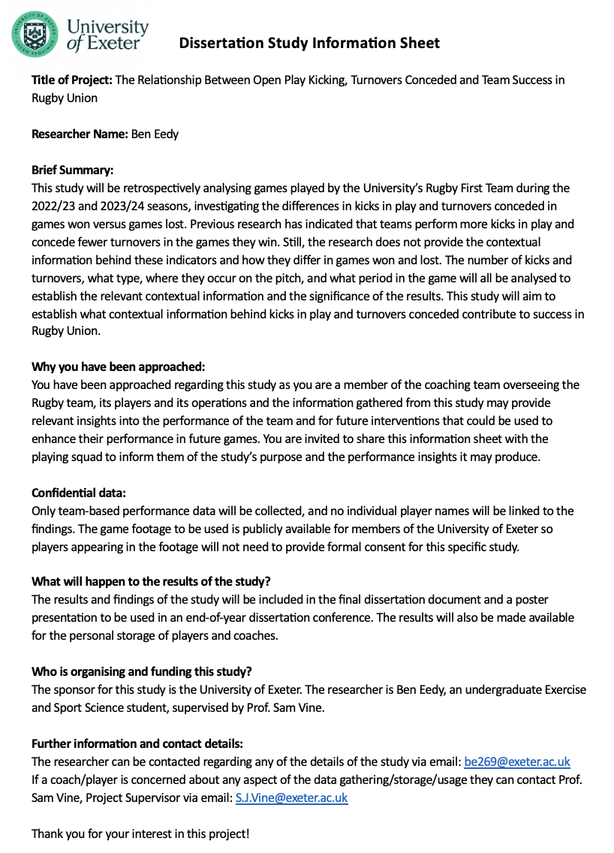

Figure 8. The Dissertation Information Sheet provided to the team being analysed as part of the study.

## Appendix B

Table 3. The list of operational definitions for each PI examined.

|  |  |  |
| --- | --- | --- |
| Kicking PIs |  | Definitions |
|  | **PI Subgroup** |  |
|  | Kick in Open Play | A kick occurring in any phase where both teams can contest for possession of the ball. |
|  | Territorial Kick | A kick which is used to gain ground by kicking it deep into the opposition’s territory rather than kicking to retain possession. |
|  | **Kick Type** |  |
|  | Competitive Kick | A kick used in open play for the purpose of competing with the opposition for retention of the ball. Is usually shorter in length than territorial kicks to allow the chance of competition |
|  | Box Kick | A kick commonly performed by the scrum half from the base of a ruck/scrum/maul. |
|  | Chip | A short, shallow kick delivered over the head of a defender, usually for the kicker or a teammate to retrieve. |
|  | Cross-Field | A kick used to transfer the ball from one side of the pitch to the opposite touchline, usually for a teammate to run onto and catch. |
|  | 50/22 | When the team in possession kicks the ball from inside their own half and the ball bounces out of play in the opposition’s 22-metre area, resulting in a lineout for the team who kicked the ball. |
|  | Kick for Distance | A kick performed usually by the first receiver for the purpose of relieving defensive pressure and putting the ball out of play or further up the field. Also, can be referred to as a clearance kick. |
|  | Grubber | A low kick usually short in length that travels by bouncing along the ground. |
|  | Other | Any other kick that does not fall into the above categories. |
| Turnover PIs |  |  |
|  | **PI Subgroup** |  |
|  | Turnover Conceded | When possession of the ball changes from one team to the other without an official change of possession via scoring, the down system, or a half. |
|  | Forced Turnover | A turnover of possession forced by the actions of the defending team. |
|  | Unforced Turnover | A turnover of possession due to the errors of the team in possession. |
|  | **Turnover Source** |  |
|  | Ruck | A turnover during a ruck. |
|  | Tackle | A turnover by the tackler/assistant tacklers. |
|  | Pass | A turnover via an interception of a pass. |
|  | Handling Error | A turnover from a knock on, forward pass or if the ball goes to ground and the opposition gathers it. |
|  | Lineout | A turnover where the opposition steals the throw into the lineout. |
|  | Scrum | A turnover during a scrum. |
|  | Maul | A turnover during a maul, via ripping the ball out of a player’s hands or forcing a collapsed maul. |
|  | Penalty | A turnover resulting from an infringement of the laws by the team in possession. |
|  | Other | Any other turnover that does fall into the above categories. |

## Appendix C

Table 4. List of fixtures included in analysis.

|  |  |  |  |
| --- | --- | --- | --- |
| Season | Opponent | Home/Away | Won/Lost |
| 2023/24 | Hartpury | Home | Won |
| 2023/24 | Nottingham | Away | Won |
| 2023/24 | Loughborough | Home | Won |
| 2023/24 | Swansea | Away | Won |
| 2023/24 | Durham | Home | Won |
| 2023/24 | Cardiff | Away | Won |
| 2023/24 | Cardiff Met | Away | Won |
| 2023/24 | Bath | Home | Won |
| 2023/24 | Leeds Beckett | Home | Won |
| 2023/24 | Nottingham | Home | Won |
| 2023/24 | Loughborough | Away | Won |
| 2023/24 | Swansea | Home | Won |
| 2022/23 | Cardiff Met | Away | Won |
| 2022/23 | Leeds Beckett | Home | Won |
| 2022/23 | Nottingham | Away | Won |
| 2023/24 | Durham | Away | Lost |
| 2023/24 | Hartpury | Away | Lost |
| 2022/23 | Hartpury | Home | Lost |
| 2022/23 | Loughborough | Away | Lost |
| 2022/23 | Cardiff | Home | Lost |
| 2022/23 | Durham | Away | Lost |
| 2022/23 | Cardiff | Away | Lost |
| 2023/24 | Luctonians | Home | Lost |
| 2023/24 | Bourneville | Away | Lost |
| 2023/24 | Redruth | Away | Lost |
| 2023/24 | Dings | Home | Lost |
| 2023/24 | Camborne | Away | Lost |
| 2023/24 | Hinckley | Home | Lost |
| 2023/24 | Luctonians | Away | Lost |
| 2022/23 | Clifton | Away | Lost |